NeuroFleetX – AI Powered Urban Fleet & Traffic Intelligence

INFOSYS SPRINGBOARD VIRTUAL INTERNSHIP 6.0
JAVA BATCH 7 – TEAM B

MENTOR
-Vinay Prashant
TEAM MEMBERS
- NARMADHA L
- GANESH S
- PAMALA DINESH KUMAR
-NITIN

Agenda:

1.Introduction
2. Problem Statement
3. Objectives of the Project
4. Scope of the Project
5. System Overview
6.User Roles and Responsibilities
7. Functional Modules
8. Technology Stack Used
9. Milestones and Project Progress
Milestone 1
Milestone 2
Milestone 3
10. Results and Outputs
11. Challenges Faced
12. Future Enhancements
13.Conclusion

1. Introduction
NeuroFleetX is a smart fleet and traffic management system designed to monitor vehicles, traffic conditions, and risk zones in urban environments.
The system connects administrators, managers, and drivers through a single platform to improve traffic awareness, safety, and operational efficiency.

2. Problem Statement
Cities are becoming more crowded every year due to the increasing number of vehicles on the road. In the future, both human-driven and autonomous vehicles will share the same traffic space. Managing such a mixed traffic environment using traditional systems is very difficult.
Existing traffic systems are limited because they:
- Cannot handle sudden traffic congestion
- Do not predict risk or accident-prone zones
- Lack intelligent route guidance
- Cannot monitor vehicles continuously in real time
To overcome these challenges, there is a need for a smart, AI-assisted system that can observe city traffic, analyze patterns, and support safer and smoother transportation. NeuroFleetX is developed to address this need.

3. Objectives of the Project
The main objectives of NeuroFleetX are:
- To monitor fleet vehicles in real time
- To analyze traffic congestion and risk zones
- To provide role-based dashboards for different users
- To assist decision-making using AI-assisted logic
- To improve road safety and traffic efficiency

4. Scope of the Project
The project focuses on building a single platform capable of managing:
- Human-driven and autonomous vehicles
- Traffic flow and congestion
- Risk zones and alerts
- Vehicle movement and trip information
- AI-assisted traffic insights
The system supports three user roles:
- Admin – Controls and manages the entire system
- Manager – Monitors traffic and fleet operations
- Driver – Executes trips and receives route guidance and alerts
Key features within the scope include login for all roles, vehicle management, live tracking, traffic data updates, congestion prediction, safe route visualization, and risk zone display on maps.

5. System Overview
NeuroFleetX follows a full-stack architecture:
- Frontend built using React for interactive dashboards
- Backend developed using Spring Boot for business logic and APIs
- Secure communication using JWT authentication
- Integration with map and AI-assisted services for traffic analysis

6. User Roles and Responsibilities
Admin
- Manages users, drivers, and vehicles
- Monitors dashboards, alerts, and analytics
- Controls system-level configurations
Manager
- Monitors traffic conditions and risk zones
- Updates traffic data
- Oversees fleet operational status
Driver
- Views assigned trips
- Follows suggested routes
- Shares location updates
- Receives traffic and safety alerts
7. Functional Modules

7.1 Authentication Module
The Authentication Module ensures secure access to the system for all users.
- Login page for Admin, Manager, and Driver
- Registration page for creating users
- Secure authentication using JWT tokens
- Role-based access control to protect system pages

7.2 Admin Module
The Admin module provides full control over the system.
Admin Dashboard
The Admin Dashboard presents an overall view of the system:
- View total vehicles
- Monitor active, idle, and stuck vehicles
- View traffic conditions and risk zones
- Display basic dashboard analytics for decision-making
User Management
- Create and manage Admin and Manager accounts
- Assign roles and control system access
Driver Management
- Add new drivers
- Update driver details such as license, contact, and experience
- View and archive driver records
Vehicle Management
- Add new vehicles
- Edit vehicle details (status, type, fuel level, assignment)
- Delete vehicles when no longer active
- Monitor vehicle status across the fleet
Alerts Management
- Create new alerts
- View all system alerts
- Resolve traffic or risk-related alerts
AI Tools
- Use AI-assisted features such as route suggestions
- Support traffic analysis and decision-making
AI Analytics
- Monitor traffic risk levels
- Analyze congestion patterns
- View analytics using charts and visual indicators

7.3 Manager Module
The Manager module focuses on traffic and fleet monitoring.
Dashboard – view traffic status, fleet overview, and risk zones
Traffic management – add and update traffic data for different locations
Risk zone monitoring – identify low, medium, high, and critical risk areas
Fleet overview – monitor active, idle, and stuck vehicles
Route explorer – view different possible routes between source and destination
Route safety – analyze safety level of routes before assigning trips

7.4 Driver Module
The Driver module helps drivers execute trips safely and efficiently.
Driver Dashboard
- View assigned trips
- Monitor vehicle status
- View active traffic and safety alerts
Trip Management
- Create trips with source and destination
- View trip details and trip status
Route Navigation
- View suggested routes on the map
- Live route tracking during trips
GPS Tracking
- Share real-time location updates during trips
Alerts & Vehicle Status
- Receive traffic, safety, and risk alerts
- View vehicle health and basic maintenance alerts

8. Technology Stack Used
- Frontend: React
- Backend: Spring Boot
- Database: MYSQL
- Security: JWT Authentication
- Maps & AI Tools: OpenStreetMap, AI-assisted logic

9. Milestones and Project Progress
Milestone 1 – PPT Presentation
- Problem definition
- Project overview
- Role explanation
- Team responsibilities
- Basic system flow
- Technology selection

Milestone 2 – Core System Implementation
In this milestone, the core system and role-based modules were implemented.
Admin Module
- Admin Dashboard
- User Management (Admin & Manager)
- Driver Management
- Vehicle Management
Manager Module
- Manager Dashboard
- Traffic Management (add and update traffic data)
Driver Module
- Driver Dashboard
- Trip Management (source and destination handling)
Milestone 3 – Intelligent Features & System Completion
- In this milestone, the remaining functional and intelligent modules were implemented to complete the system.
Admin Module
- Alerts Management
- AI Tools
- AI Analytics
Manager Module
- Risk Zone Monitoring
- Fleet Overview
- Route Explorer
- Route Safety

Driver Module
- Route Navigation
- GPS Tracking
- Manual driver check-in
- Trip Monitoring
- Alerts

10. Results and Outputs
- Role-based dashboards
- Live traffic and vehicle data
- Alerts and analytics visualization
- Map-based route and risk display
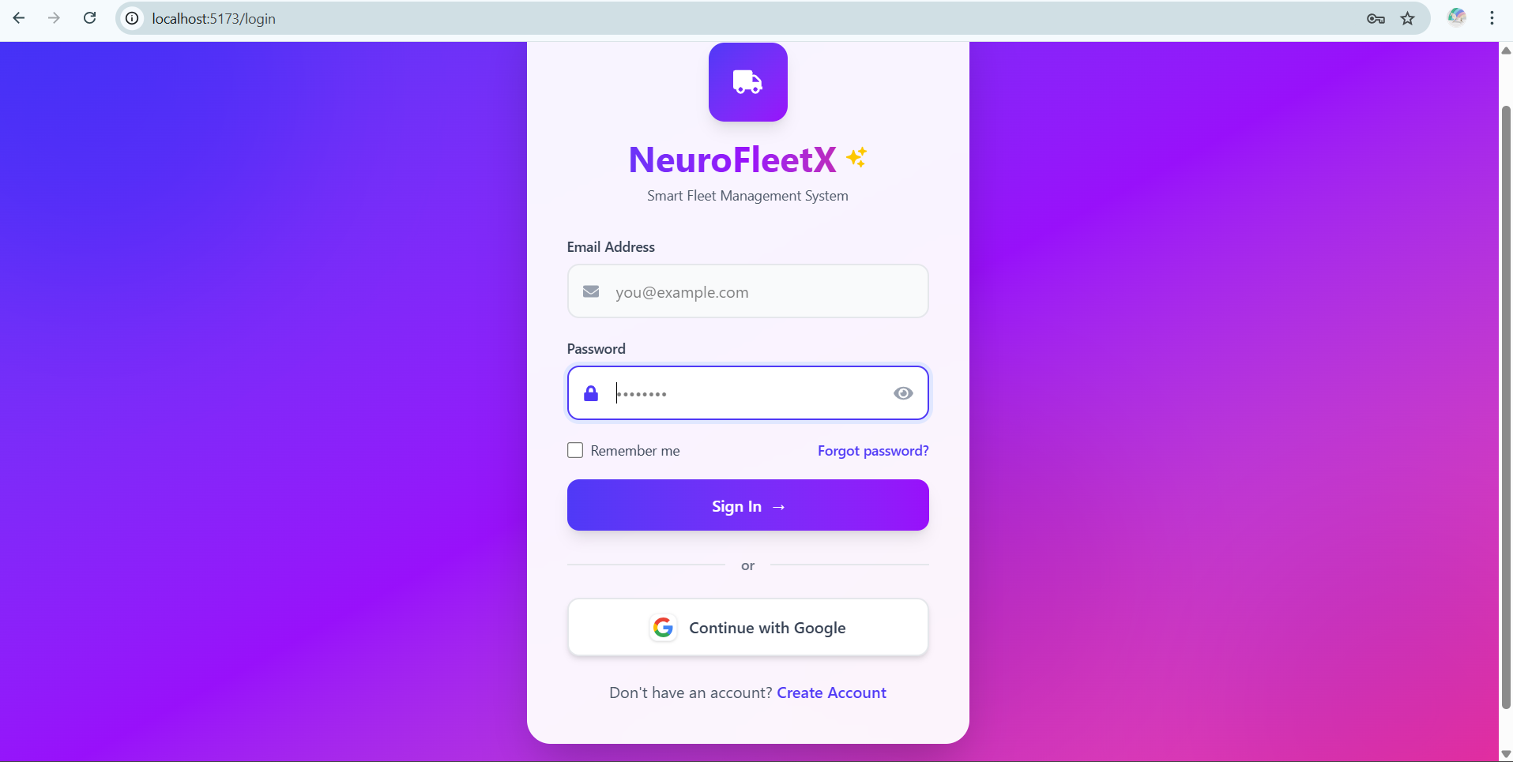
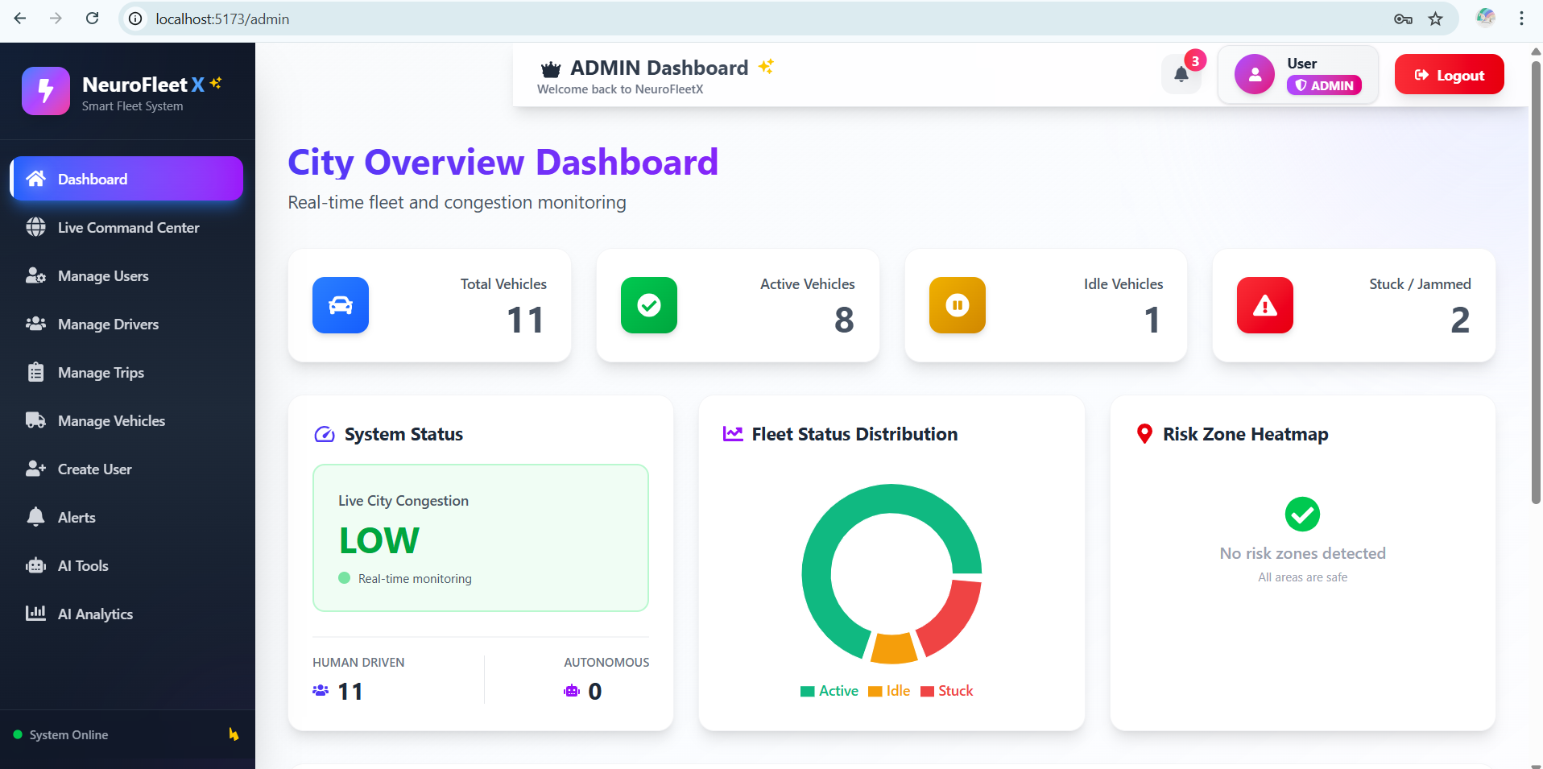

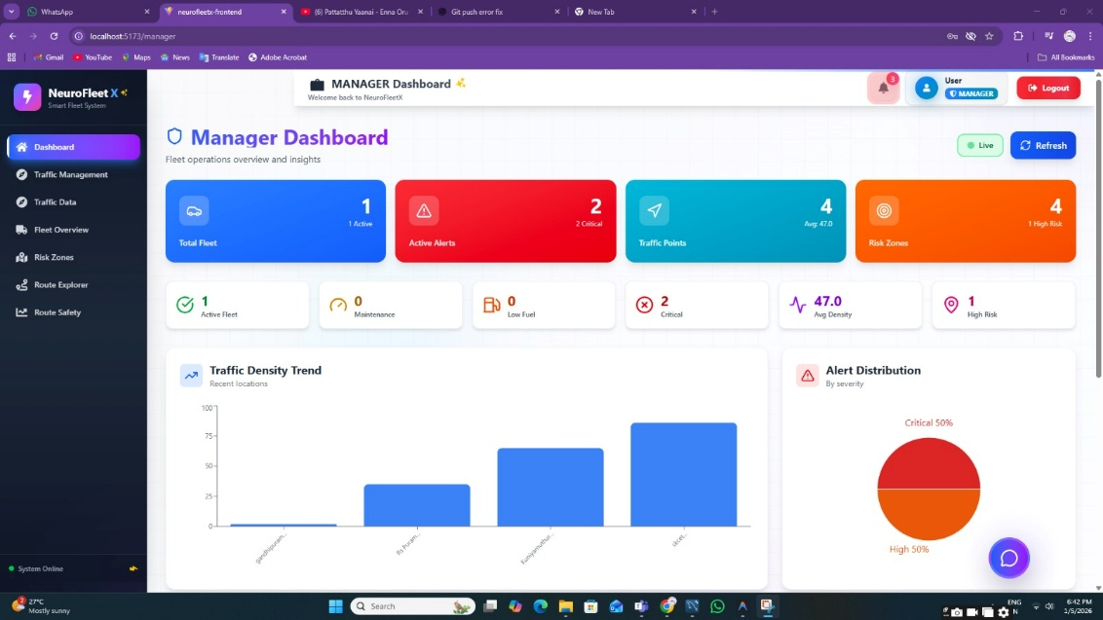

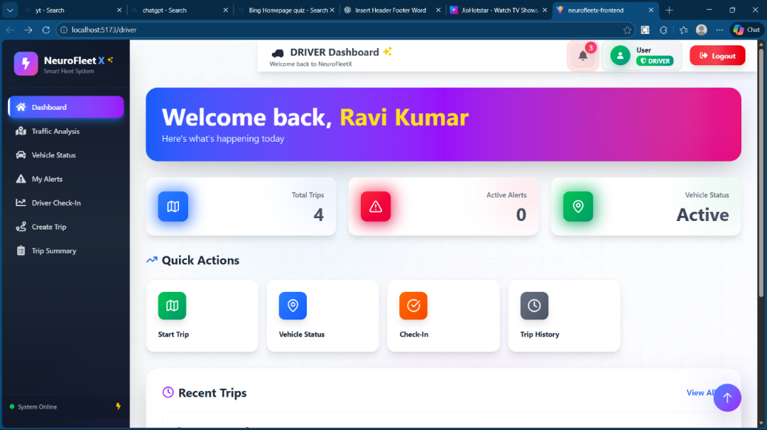

11. Challenges Faced
- Handling real-time traffic data
- Location resolution issues
- Managing role-based access securely
- Integrating AI-assisted logic effectively

12. Future Enhancements
- Advanced ML-based traffic prediction
- Large-scale real-time data integration
- Autonomous vehicle optimization
- Predictive maintenance analytics

13. Conclusion
NeuroFleetX successfully demonstrates a smart, role-based fleet and traffic management system. With AI-assisted analytics, alerts, and dashboards, the system improves traffic awareness, operational efficiency, and safety. The project provides a strong foundation for future intelligent transportation solutions.

